cukkah (סֻכָּה) [5520]
Leviticus 23:34-43
The Purpose:
- This feast was ____________ of when Israel lived in temporary _________________ in the ____________________
- The feast is also _________________, looking forward to the time that Messiah would _________ and that the Presence of God would ___________ among Israel

The Time:
- The feast began on the _____^{th} day of the ____^{th} month
- This feast last for ____ days, with a _________ on the ____^{th} day

The Structure: Building the Booth
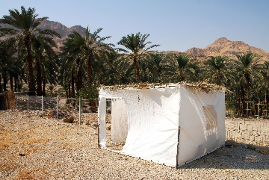

The Lulav
- Leviticus 23:40
- This is four species of foliage that are waved by the people every day
  - Palm branch: symbolized _________
  - Myrtle branch: symbolized _________
  - Willow branch: symbolized ____________
  - Etrog: symbolized ____________________
The Rite of the Water Libation
- The relevance of pouring out the water:
  - One: The Gihon Springs connected to _________________
    - This was where the kings of Israel were anointed
  - Two: The water represented the ____________ out of the ___________ ___________
    - The anointing of the kings of Israel was symbolic of the Holy Spirit coming upon the kings
- The Connection to Christ:
  - John 7:37a
  - John 7:37b-38: Jesus was announcing to everyone who heard that He was the promised __________ and that He would pour out the ___________ ___________ on the people (read v. 39-41a)

The Fulfillment
- The Shekinah glory of God will serve as a ____________________ over the Temple
- God’ Presence will return to Mount Zion, and He will ___________ with His people once more, but this time, He will not depart (Ezekiel 43:2-7)
- During the Feast of Tabernacles in the Kingdom, we will _________ the King and the Holy Spirit will be ____________ _________ on the Israelites

